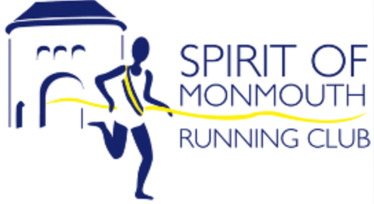
SPIRIT OF MONMOUTH RUNNING CLUB
GUEST RUNNER FORM

Welcome to Spirit of Monmouth club night. We hope you enjoy your run with us.
Please complete this form and return it to the Membership Secretary, by email: spiritofmonmouth@gmail.com,

Surname……………………………. First name………………………
Male/Female……………………….. Date of Birth…………………….
Address……………………………………………………………………
Post code………………………….. Email……………………………..
Home tel. no………………………. Mobile no………………………..
Emergency contact name………………………………………………
Emergency contact tel. no……………………………………………..

I declare that I am fit and healthy and there is no medical reason why I should not run.
I consent to my details being provided to Track, Trace and Protect in the event of a member of my group becoming unwell with Covid 19.

Signature…………………………………………..Date………………..

